1) http://165.22.217.185/layout/doctorView/9
Hospital Address and Residential Address “ : “ misaligned.

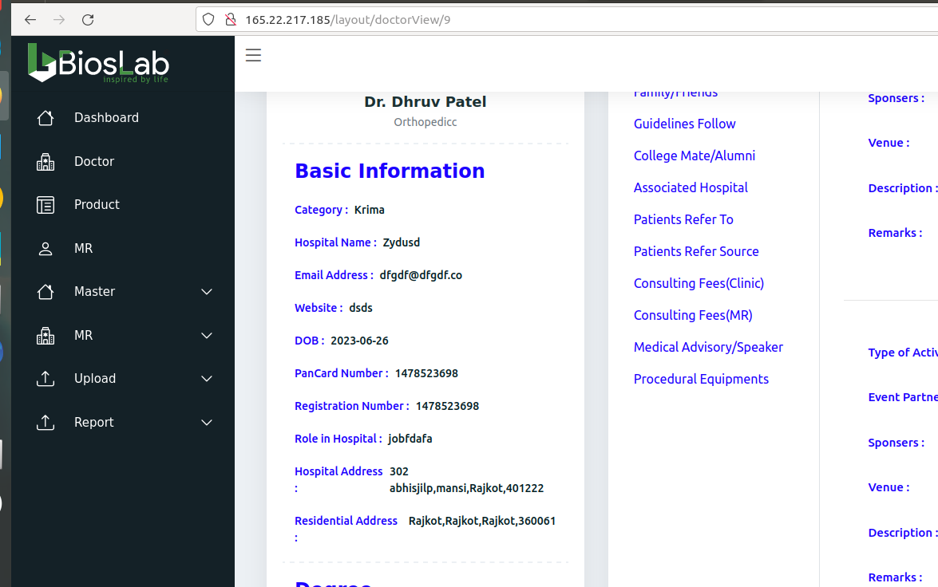

2) http://165.22.217.185/layout/doctorView/9
Update Docotor profile photo does not work
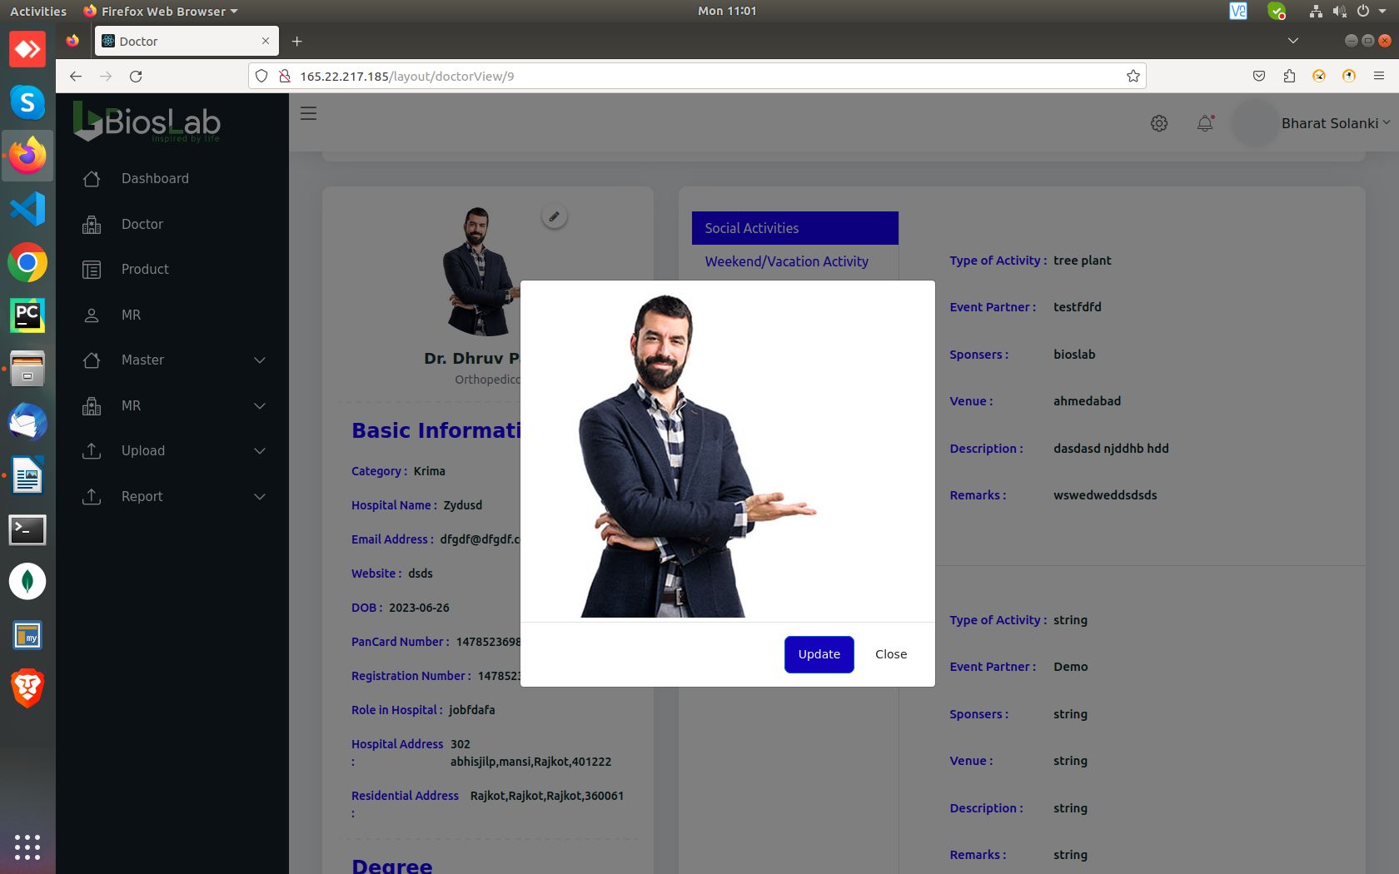

3) http://165.22.217.185/layout/doctorDetail/9
Required field message not showing up in area of interest, Area Of Interest In Medical Field, Create new area of interest, Doctor area of interest

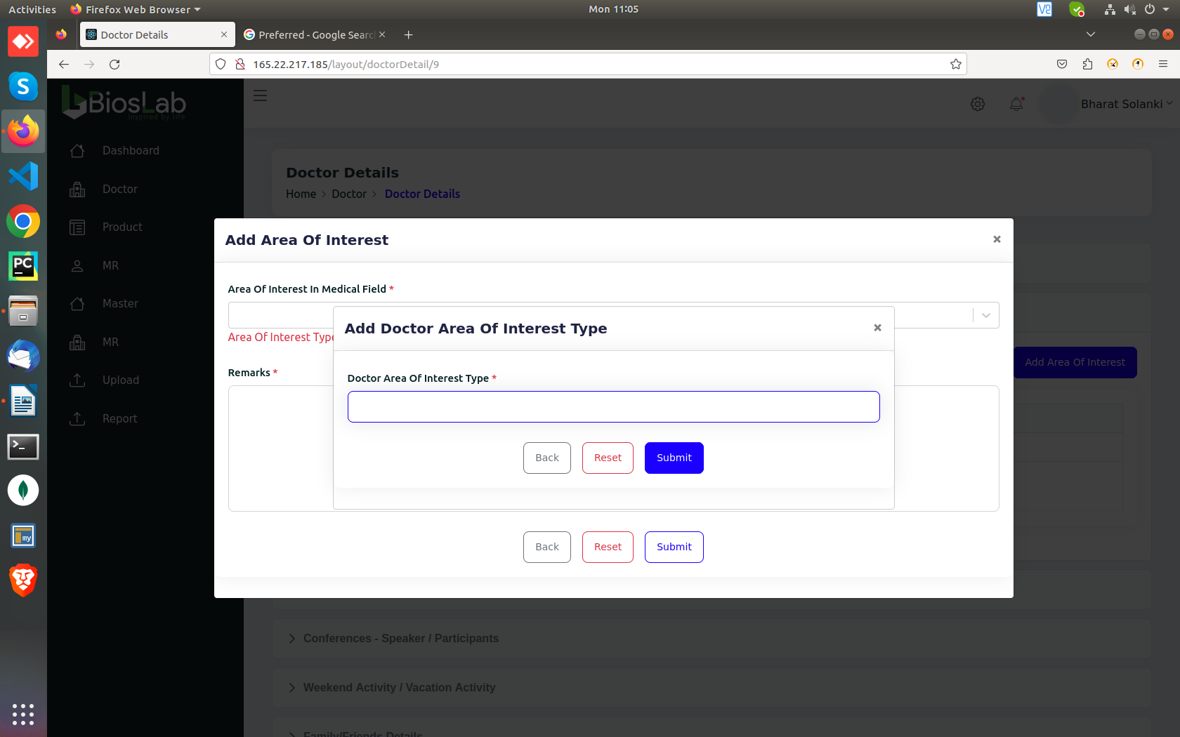
4) http://165.22.217.185/layout/AddDoctor
Can’t scroll through “City” and “pincode” using Keyboard arrow keys
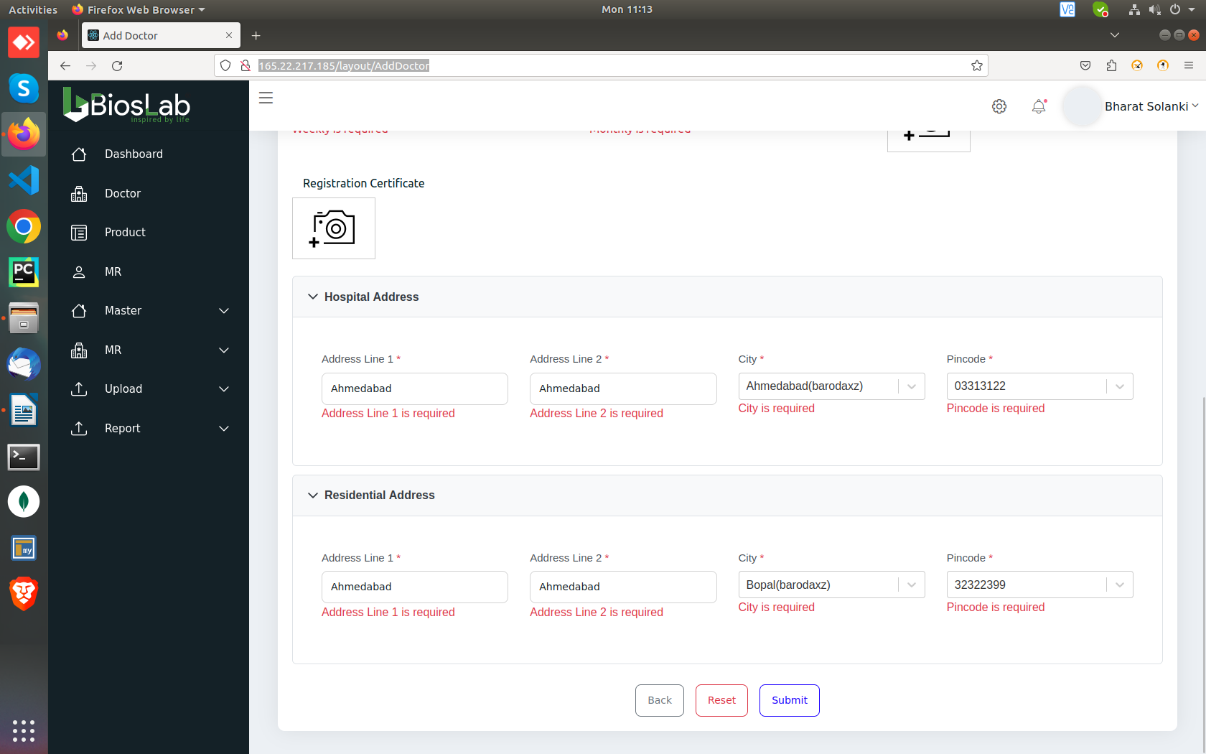

5) http://165.22.217.185/layout/AddDoctor
“Speciality”, “Pacard Image” and “Registration Certificate” Field required Error message not showing up.
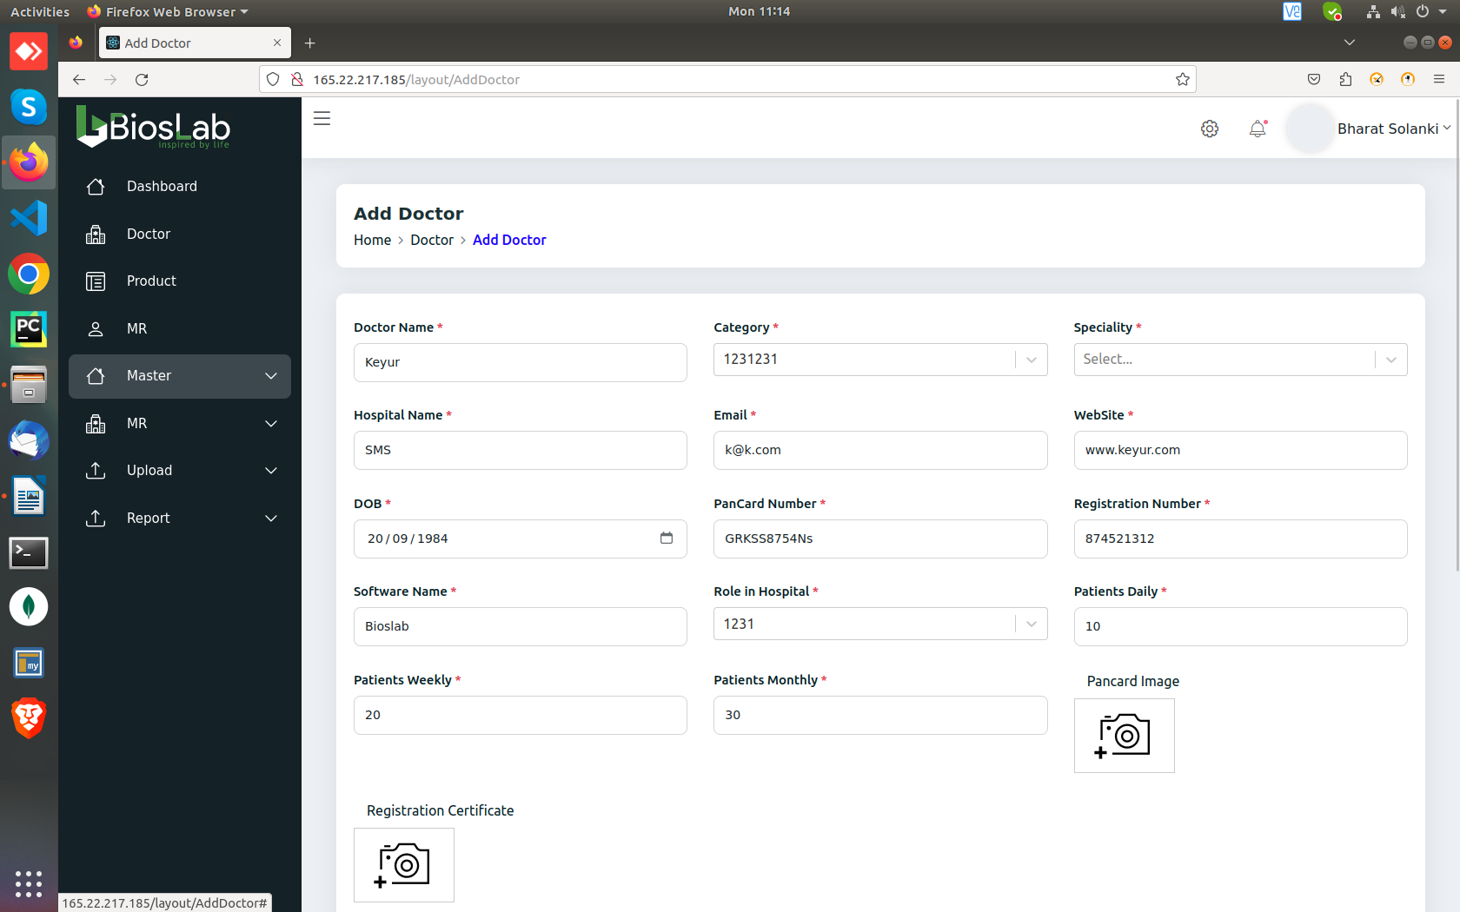
5) http://165.22.217.185/layout/AddDoctor
“Reset” does not reset: Category,Speciality, Role in hospital, Pancard image, Registration Certificate, City, Pincode

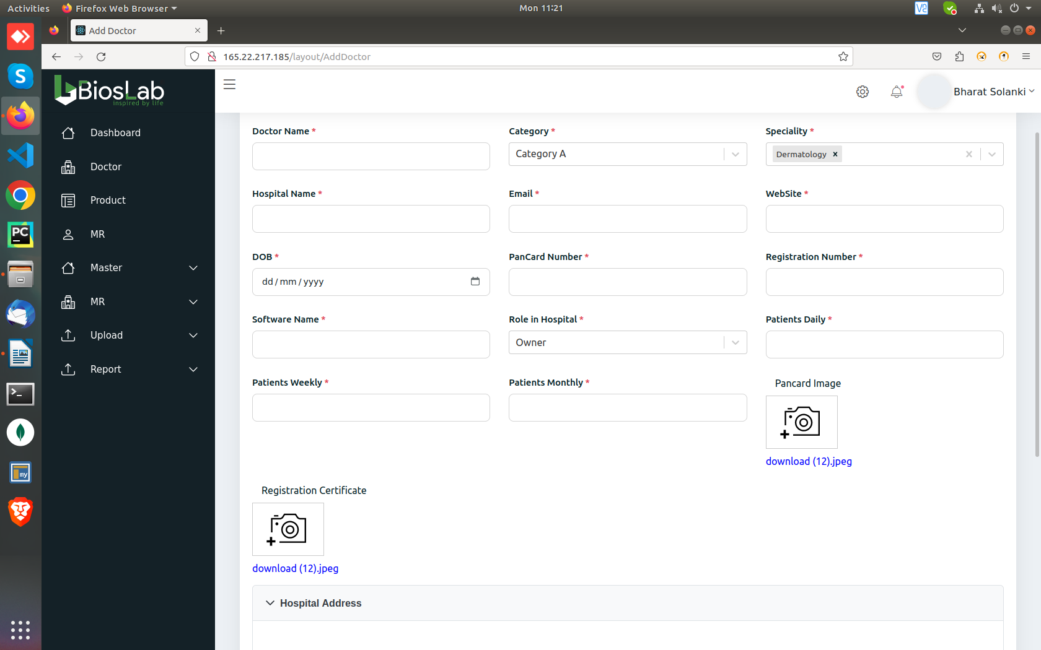

6) http://165.22.217.185/layout/AddDoctor

Error messages not showing up properly
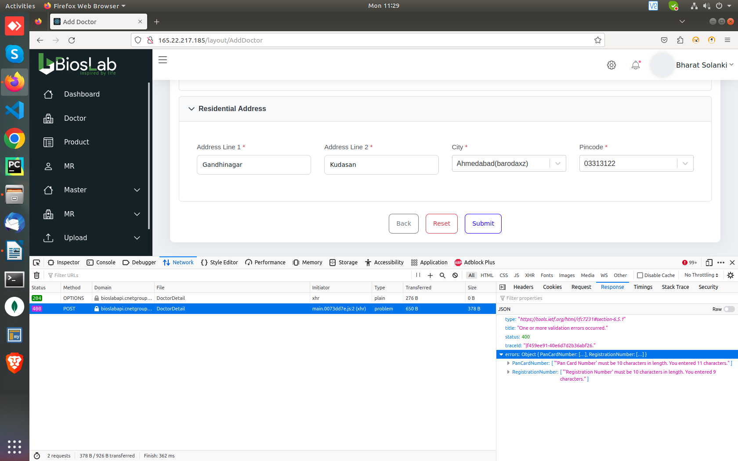

7) http://165.22.217.185/layout/doctorDetail/40
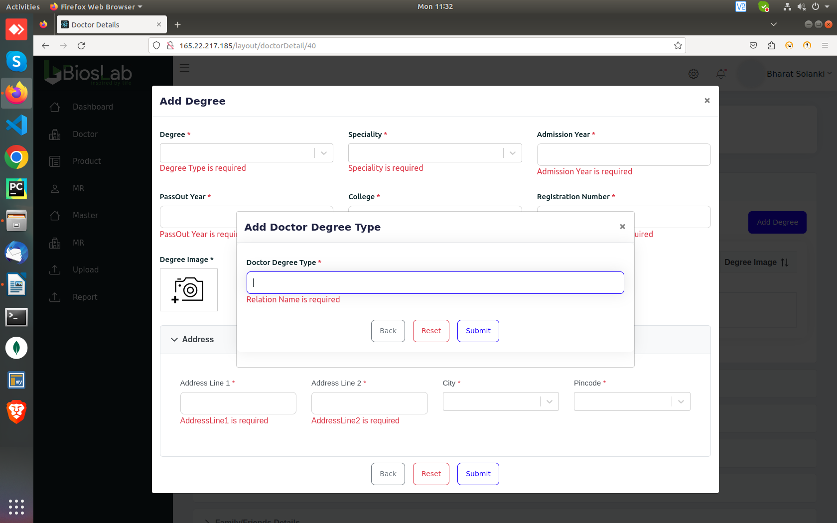
in add degree, creating new degree, shows “Relation name” instead of “Doctor Degree” message

8) http://165.22.217.185/layout/doctorDetail/40
“add degree” if we select City, “pincode required” error doesn’t show up

9) http://165.22.217.185/layout/doctorDetail/40
“Add weekend/Vacation activites” Activity type, creating new activity,shows error message “Entertainment Sactivity”
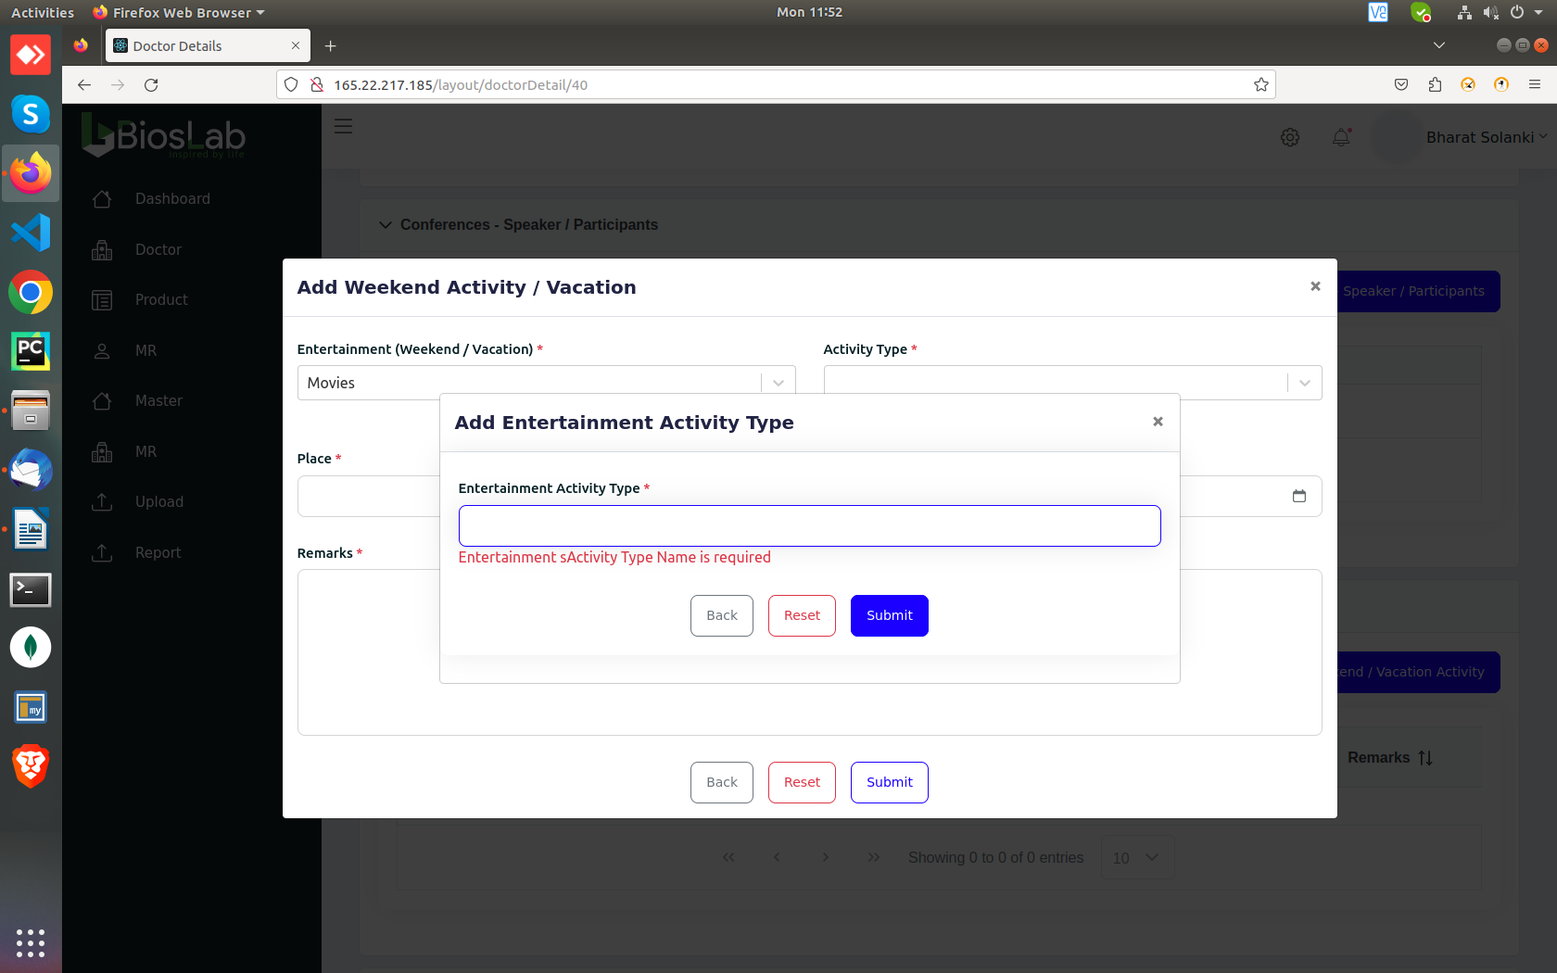
10) http://165.22.217.185/layout/doctorDetail/40 (Add patient refer source)
“Doctor Website required” Error message instead of “Name of doctor”

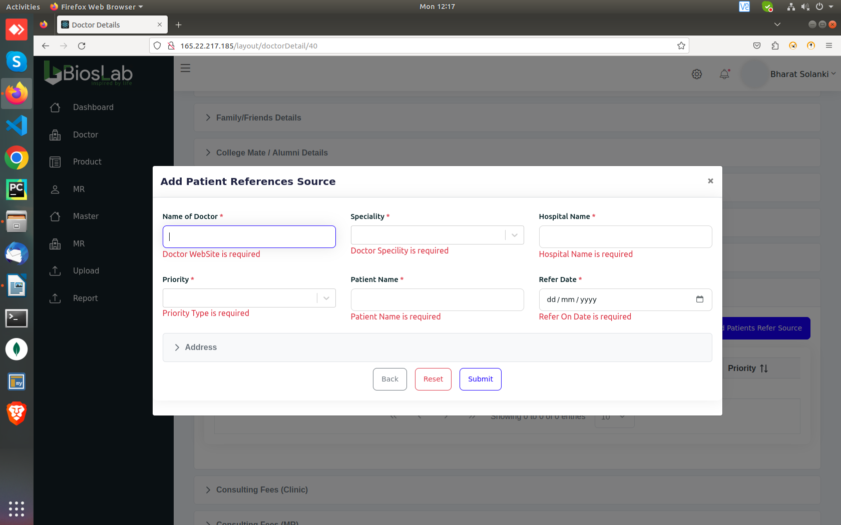

11) http://165.22.217.185/layout/doctorDetail/40
in add consulting fees clinic, create case type shows “Confere...” instead of “fee type”

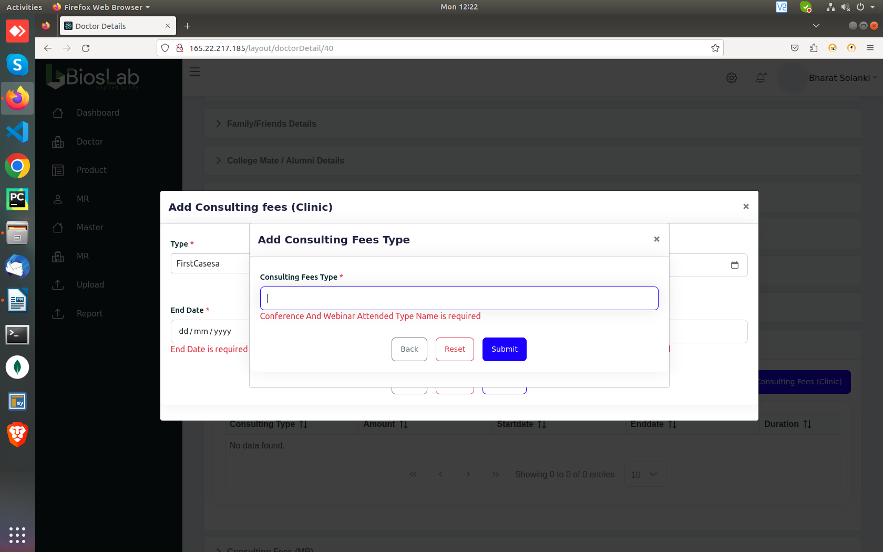
12) Multiple fees type with same can be created
13) shows red error banner without any details
ConsultingFeesForPatienDuration | [ "'Consulting Fees For Patien Duration' must be between 2 and 50 characters. You entered 1 characters." ]

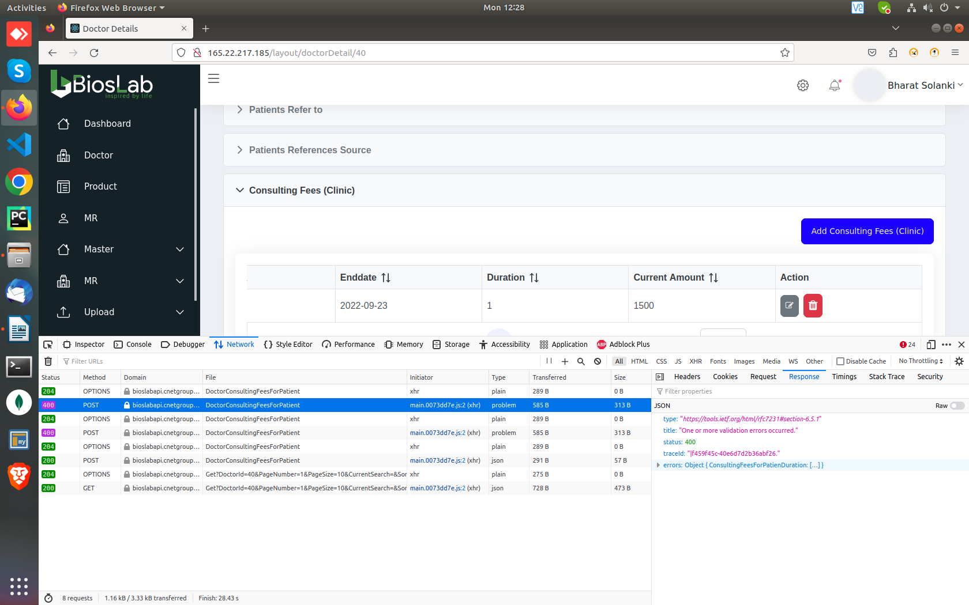

14) Add consulting (MR)
shows red error banner without any details
ConsultingFeesForMrvalidUpto | [ "'Consulting Fees For Mrvalid Upto' must be between 2 and 50 characters. You entered 1 characters." ]

Spelling Mistake:
“Additional Details” in Add doctor
“Preferred” in http://165.22.217.185/layout/doctorView/9 weekend/vacation
“Special” in http://165.22.217.185/layout/doctorDetail/40 Family/Friends Details in “Special day”, “Special day required” Error message, “Special date required” error message.
“Sponsors” in http://165.22.217.185/layout/doctorDetail/40 “Add social activities”
“Speciality” in http://165.22.217.185/layout/doctorDetail/40 “Add Patients refer to” speciality error message
“Speciality” in Add patient refer source “Speciality” error message

